The Lighting poverty problem in Lang village of Dolpo
Introduction:
Dolpo situated in the north western part of Nepal, in the trans-Himalayan region, off the rain shadow of Himalayas bordering Tibet is home to some of the highest human settlement on earth. The villages lie at the height of 3700-4300 metre above sea level and are of semi desert type. Climate is so harsh that it gets down to -30 to -40 degree Celsius in the winter. Most of villages have only two crops; potato and barley. And with the animal husbandry, the inhabitants barely make a subsistence livelihood.
In the heart of Dolpo, there lies Dho Tarap Valley. It is situated in Dolpo Buddha Rural Municipality of Dolpa District in the new state structure. The two villages; Dho and Tokyou with around 220 households in the valley with around 1500 population is one among the other regions in Dolpo which is known to outsiders and a visiting place tourists.
But there is a small village called Lang with 29 households at the southeast of Dho Tarap valley; two hours walk distance down the stream and then an hour distance up the stream leading through gorge trail to a completely isolated place. There are around 130 people living in that village.
Multi-facet problem:
Lang might be the only place in Dolpo which is almost unknown to the outsiders both local and foreign tourists. Due the remoteness there is no modern school or health post in Lang village. There are more than 40 children below 15 who don't go to school because the government primary school buildings are ruined and teacher have not came for many years. If Parents wish to send their children to Crystal Mountain School at Dho Tarap valley, they have to walk for 3 hours through a difficult terrain just to reach the school which is almost impossible for them as the school couldn't afford boarding facility till now. The same problem the people of lang face in order to get health services. There is no medicine there. Some die before the health worker comes. The inhabitants barely make a subsistence livelihood with farming, animal rearing, taking loan and most children earn their living and help their family by working in the house of the nearby villages. These often lead them to food insecurity and malnutrition. Poverty is rampant that most of the families are in heavy debt. Child and maternal mortality rate is high and life expectancy of the people is below fifty.
And one of the main problems that is related with poverty is lack of access to electricity. Their life without modern lighting is a full of darkness so as without education and others. For lighting and warming the house, it’s the duty of children to gather as much as fuel like firewood and dung. People have no choice other than using kerosene for lighting which is very expensive even with other disadvantages like dangerous and unhealthy, poor illumination and carbon emission. With the poor ventilation system of housing, most of people face eye and respiratory problems after using firewood and kerosene.
Solution:
Since access to electricity and poverty are closely linked, it's said that the countries that have lowest levels of electricity also have the highest levels of poverty. Thus we feel to have access to electricity and lighting for the people of Lang is the only way to get rid of the problems they are facing and make their present and future bright. With the lights and electricity, we hope one day soon the school will open and the teachers will come where the children of Lang will get to learn modern education for the first time. Hope government health workers will also come to serve the people and there will be less health problems related with lack of electricity and excessive use of firewood and kerosene. Children are not needed to collect fuel any more or less than before. People don't have to buy no more kerosene.
But it's impossible for them to have added to grid electricity. And the best solution in Lang where there is 300 sunny day per year and high clear air will be installing solar energy of around 10-15 kilowatt capacity (or as per your project plan) which would be enough for the entire village for lighting, heating and others purpose.
Conclusion:
Thus we would like to request you to help us with this project to come true for this remote and backward village of Dolpo in the first phase. With this project the lives of the people will change and otherwise will be in darkness and uncertainty. So, we are ready to help you to carry this project in any way that you want-either carrying the project by our organization-Vision Dolpo (www.visiondolpo.org) or assisting your organization. As the lack of access electricity is also a big problem for the people of Dho Tarap valley, we kindly request your organization to help with this solar power project in the second phase.
Thanking you.
Prepared by
Gyalpo Thapa Bhote
Project Cordinator
For Vision Dolpo
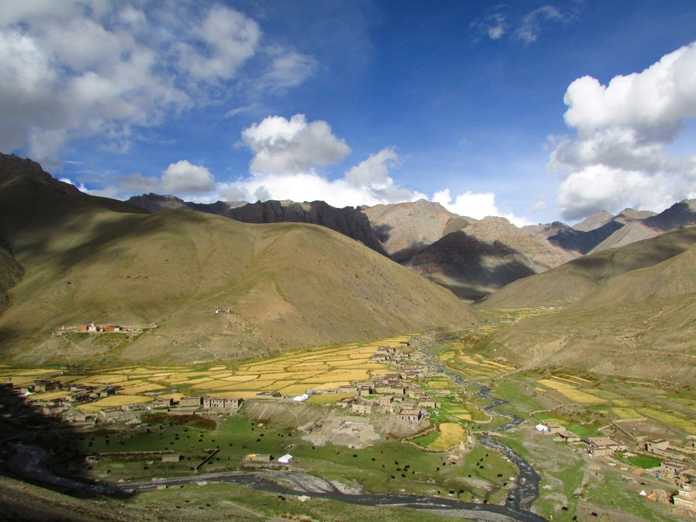
Dho-Tarap Valley
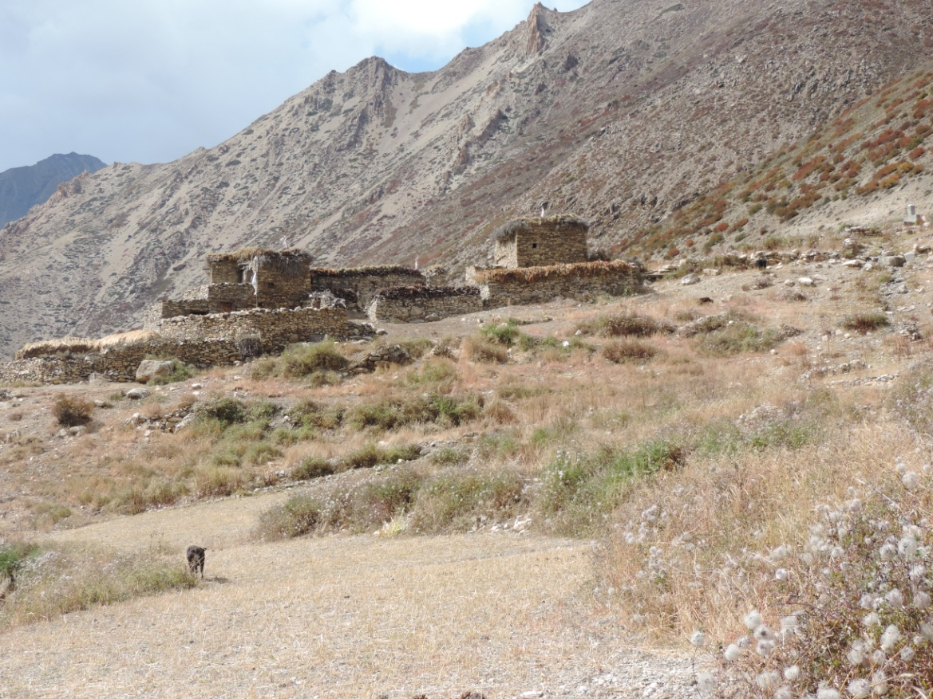
Lang-Gyapcho where 12 families live
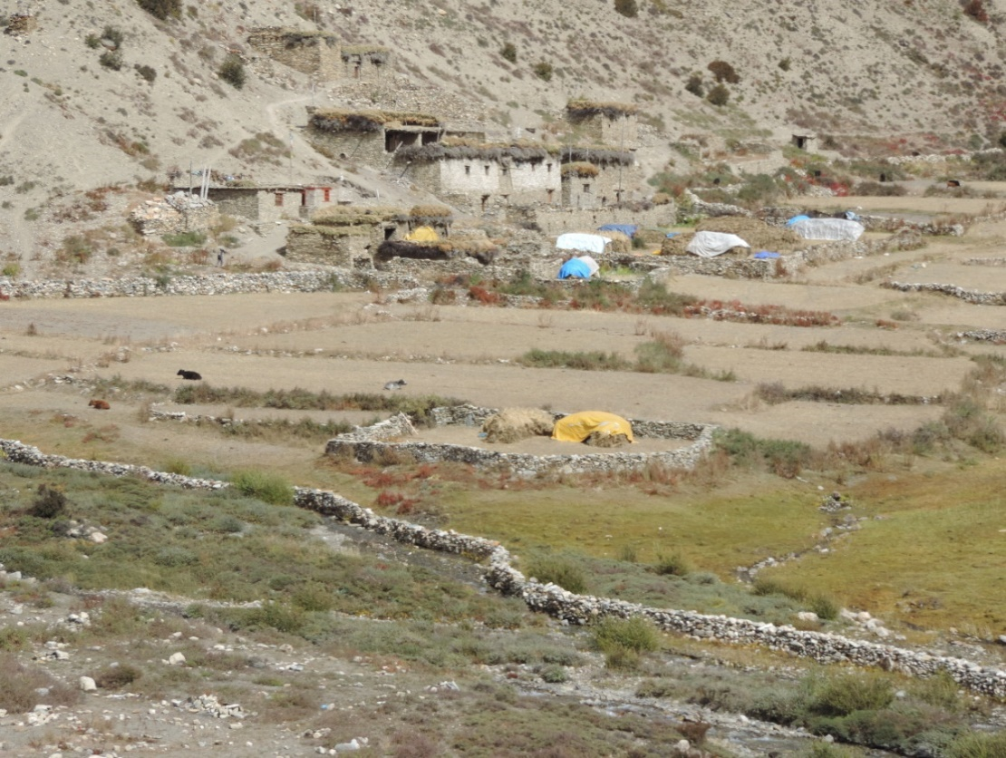
Sumdo lang, 13 families live here
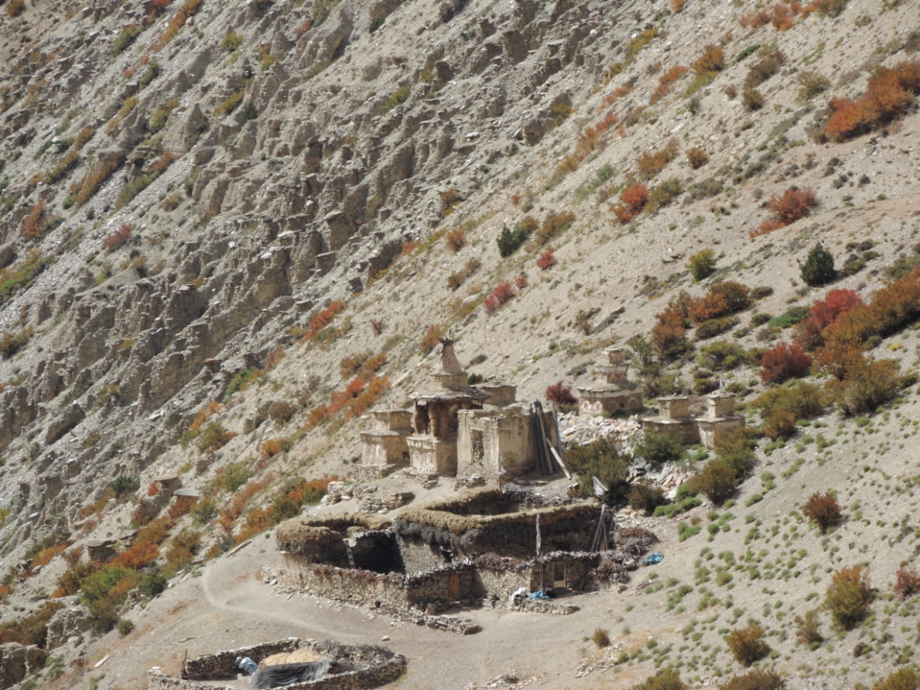
Kirting Lang-4 families live here

